Building From Tags

This section will guide you to:

* Configure a build job in Jenkins to build from a Git tag

This lab has three sub-sections, namely:

1. Adding the Git parameter plugin to Jenkins

2. Creating a tag in Git

3. Building a project from a Git tag in Jenkins

**Step 1:** Adding the Git parameter plugin to Jenkins

* Go to Jenkins **dashboard**.
* Click on ***Manage Jenkins*** in the Jenkins dashboard and select ***Manage Plugins***.

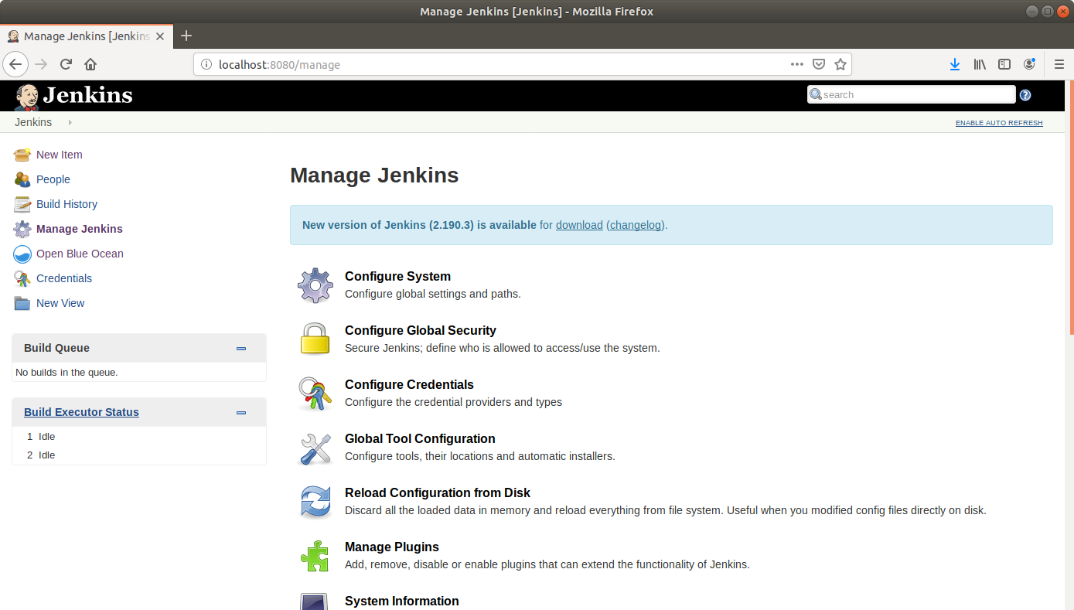

* Under the ***Available*** tab, select ***Git Parameter***.

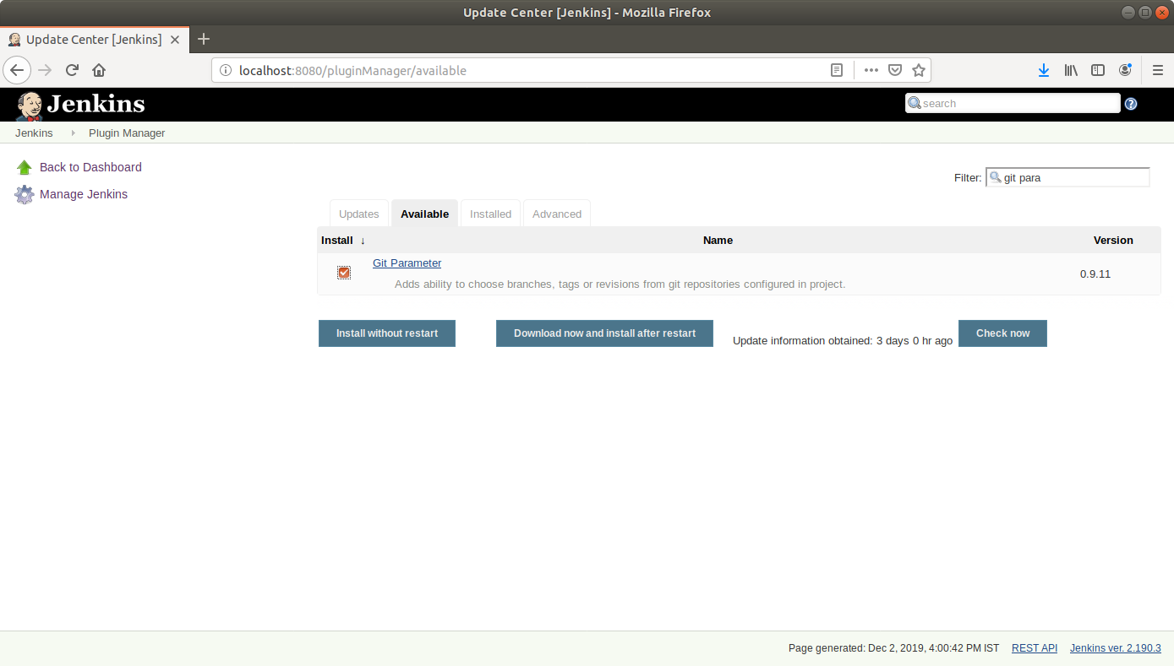

* Click on ***Install without restart*** and the plugin will be installed.

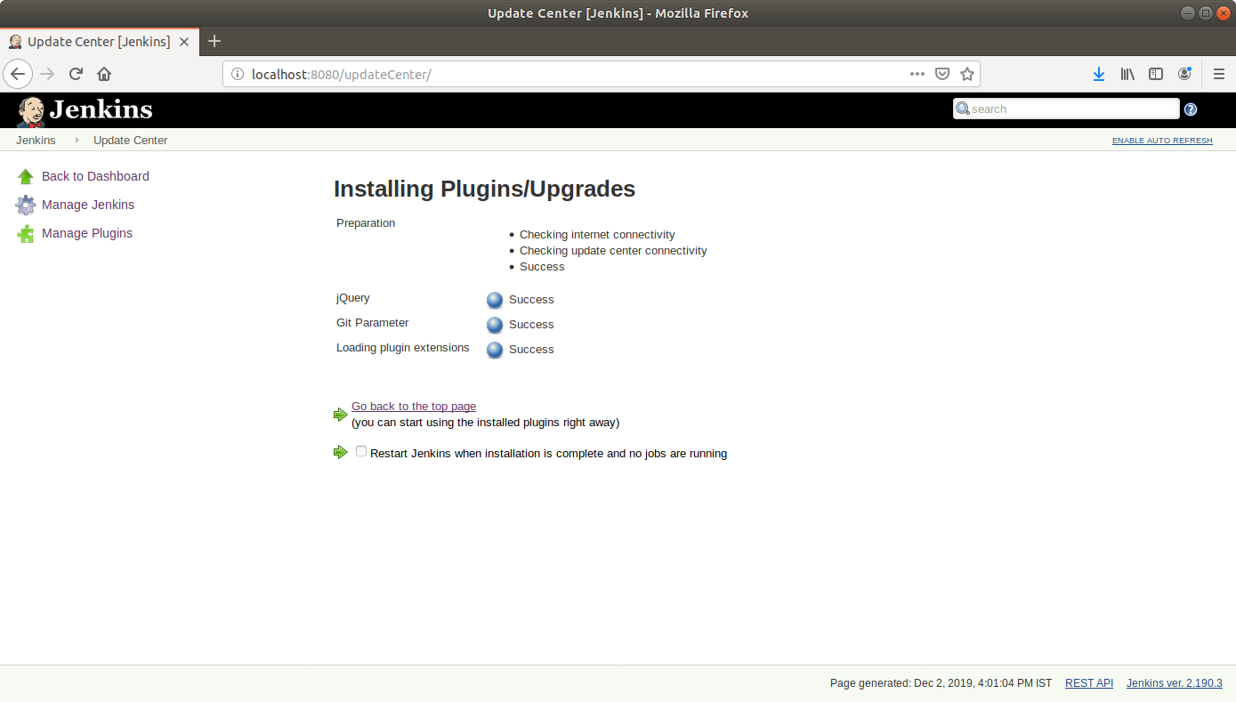

**Step 2:** Creating a tag in Git

* Go to **github.com** and open a repository.  
    
  **Please note:** You can use the **sample-java-maven-app** repository that we created in the previous demos. You can also use any other repository that you had created earlier.
* Click on the releases tab.

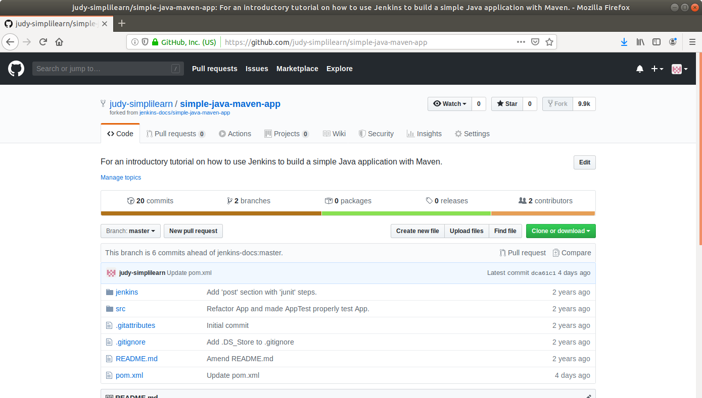

* Click on the ***Create a new release***button*.*

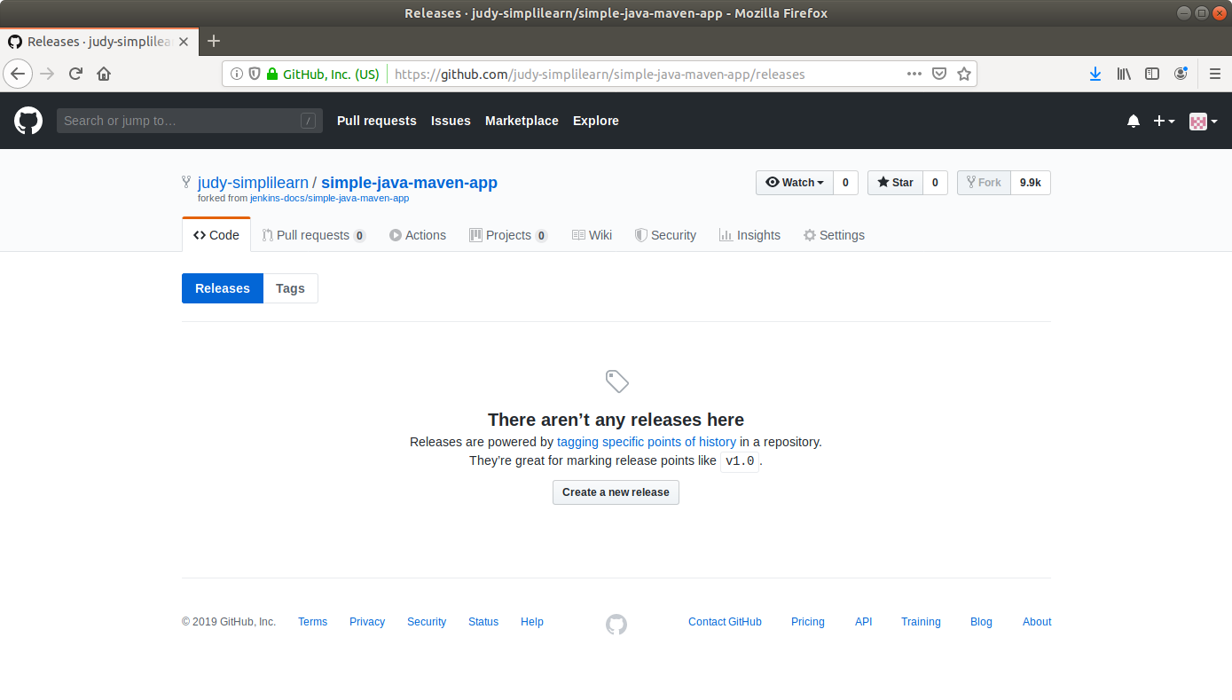

* Enter a **tag name** and fill out the other form fields.

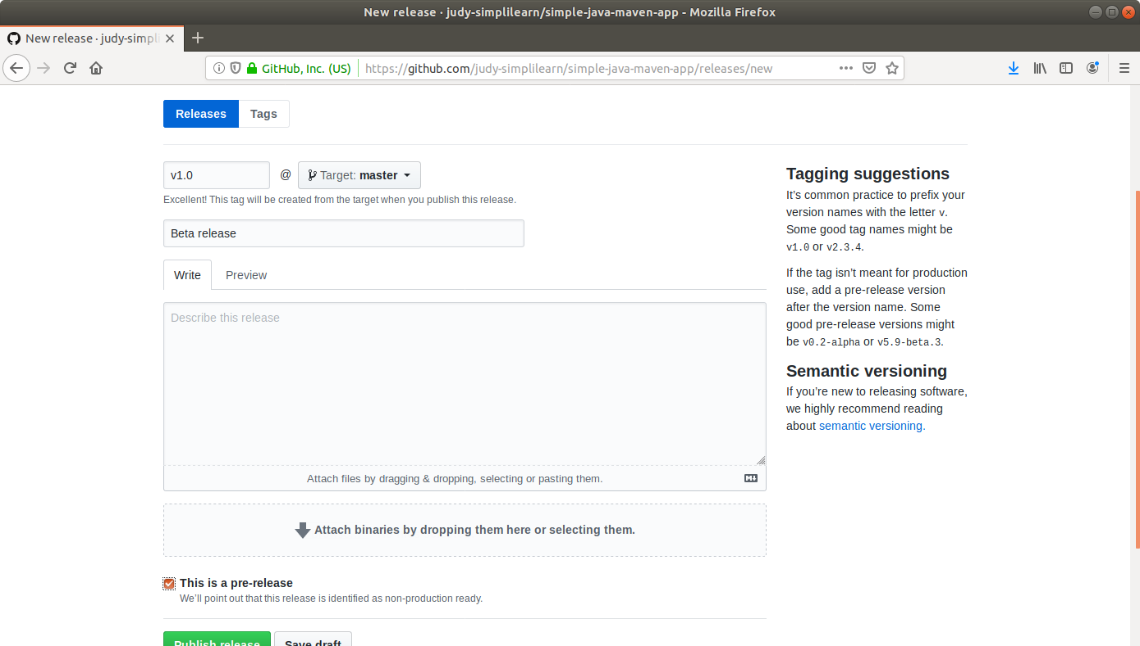

* Click ***Publish release*** at the bottom.

**Step 3:** Building a project from a Git tag in Jenkins

* Go to Jenkins **dashboard**.
* Click on ***New Item*** in the Jenkins dashboard.
* Enter a **name** for your build job.
* Select ***Freestyle project***as the build job type.

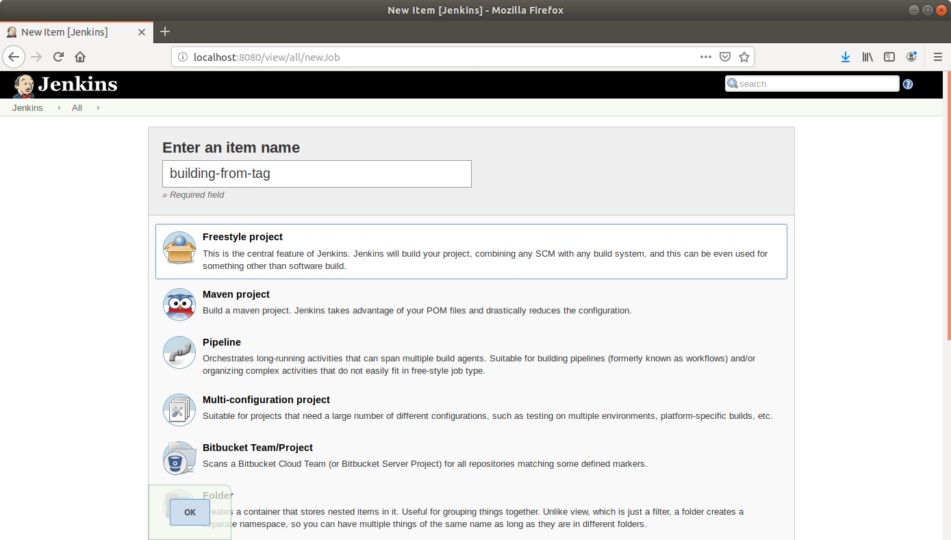

* Click **OK**.
* On the configuration page, select the checkbox next to text that states,***This project is parameterized*.**
* Click on the ***Add parameter*** button that appears.

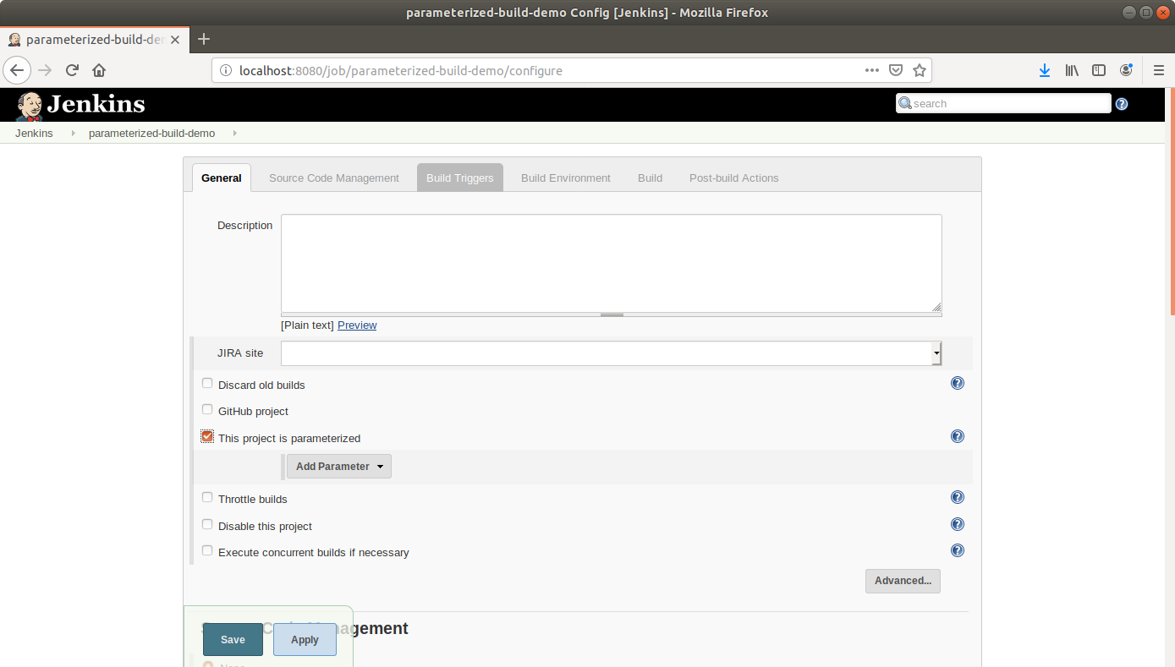

* From the drop-down menu that appears, select ***Git parameter***.
* Name the Git parameter **tag**, and choose parameter type ***Tag***.

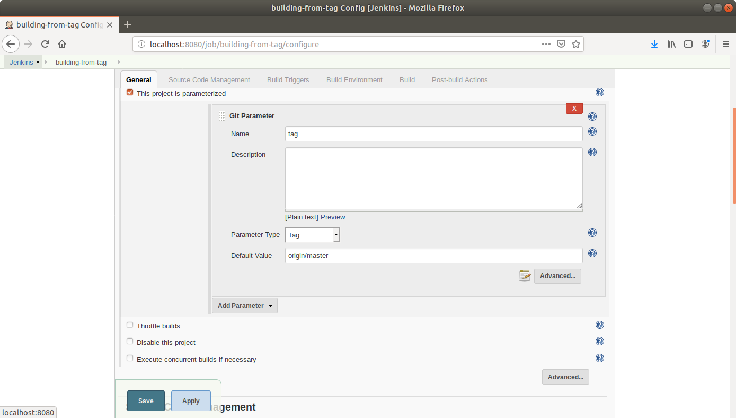

* Add a default value (**origin/master**).
* Scroll down to the Source Code Management section and select ***Git***.
* Enter the link to the repository in the field that appears.

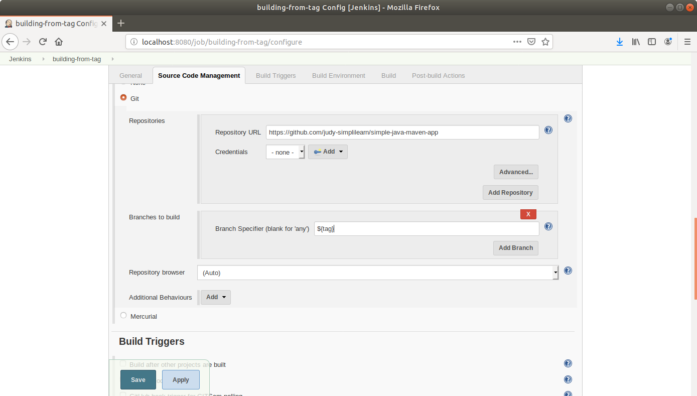

* In the *Branches to Build* field, enter the variable name as, **${tag}**
* Click **Save**.
* Click ***Build With Parameters*** in the project window to make sure the build works.
* In the page that appears, accept the defaults if correct or enter the tag value, and click the ***Build*** button. Jenkins will now build your project.

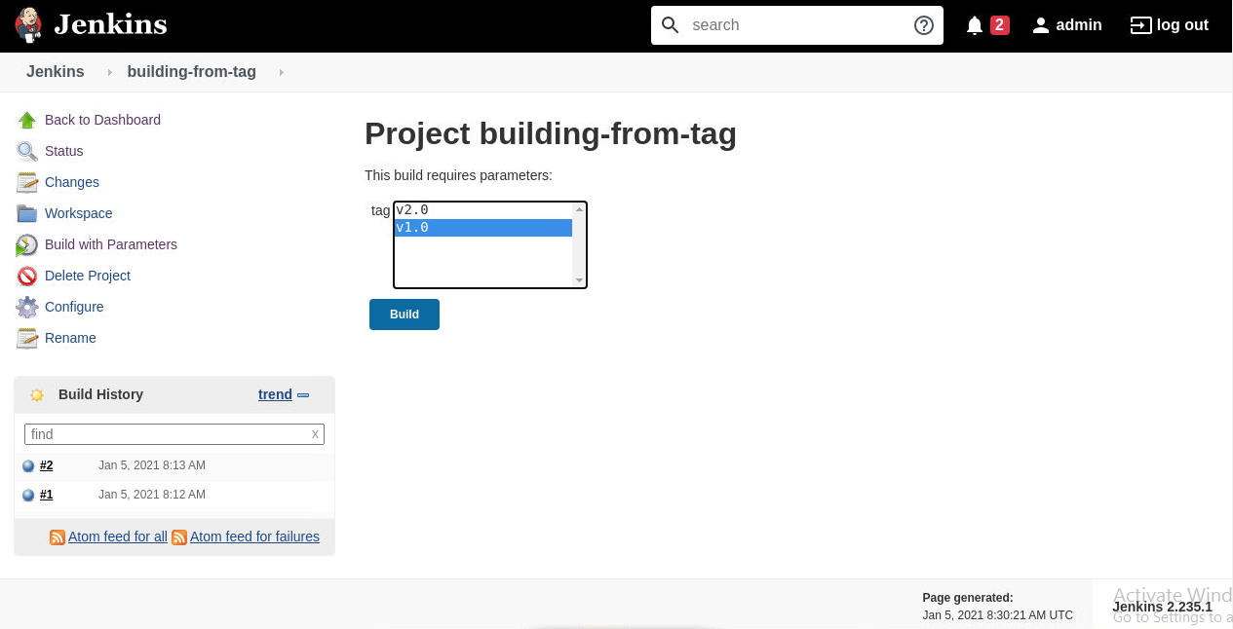

* Click on the ***Build History***to view the build results.
* Click on the ***Console Output*** to view the build logs.

